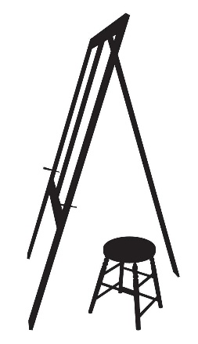
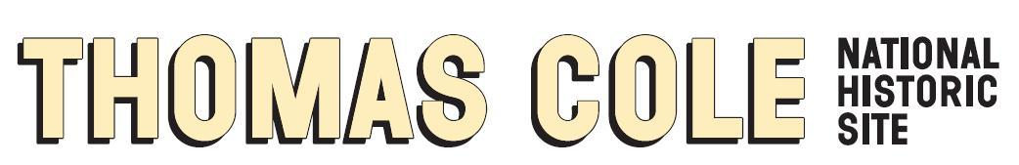

FOR IMMEDIATE RELEASE
Contact: Jennifer Greim, jgreim@thomascole.org
Director of Advancement & Ext. Relations

Thomas Cole National Historic Site Announces Completion of New Digital Education Prototype, A Program of the Jack Warner Gateway to Learning

The Free Digital Experience is Designed to Teach the Curriculum and is Being Piloted with Regional Teachers and Students for User Feedback

Catskill, NY – September 28, 2022 – The Thomas Cole National Historic Site announced today the completion of a new digital education prototype, a program of the Jack Warner Gateway to Learning: Exploring American History Through American Art.

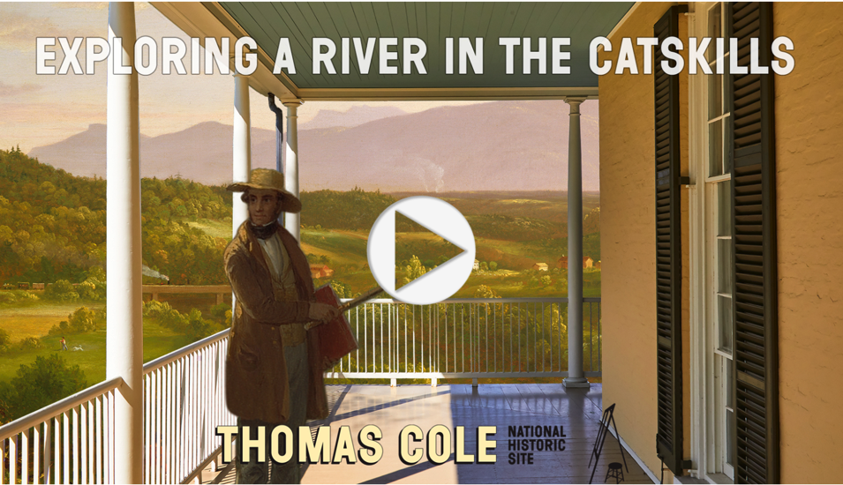
The first adventure module transforms Thomas Cole’s painting, River in the Catskills, 1843, into a digital world that students can enter and navigate. Considered to be the earliest known American oil painting to depict a train, River in the Catskills provides the artistic setting to engage students with diverse historic accounts of Industrialization in the United States and teach school curriculum. Although the painting at first appears to be an idyllic scene, further investigation reveals ideas concerning the kinds of social, environmental, and industrial conflicts that come with the development of a rural area.

Users meet a variety of historic figures with clashing perspectives on land development and make choices that lead to different outcomes. The experience is inspired by documented accounts of historic individuals, including the president of the Canajoharie & Catskill Railroad, Thomas Cooke (1778-1853), and a young Catskill resident, Peter van Vechten Jr. (1827-1913).

The prototype module is web-based and free at https://thomascole.org/exploring-a-river/. This in-progress program is currently being tested in classrooms by regional teachers. If you are a teacher interested in testing the prototype with your students and providing feedback, please get in touch at education@thomascole.org.

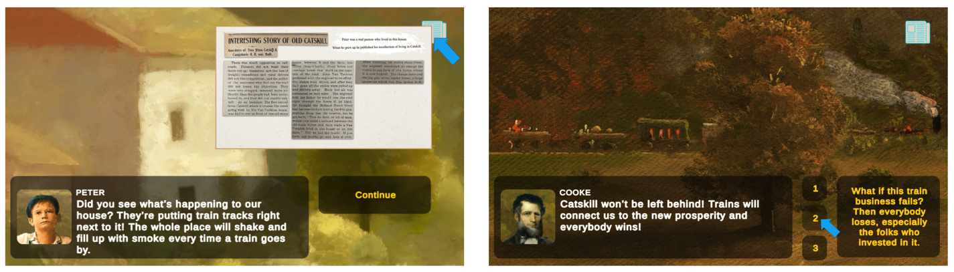

Exploring A River in the Catskills is a program of the Jack Warner Gateway to Learning: Exploring American History Through American Art, produced by The Thomas Cole National Historic Site.

The dialogue text is by the beloved Penguin Random House children’s book author and illustrator, Hudson Talbott. Talbott has written and illustrated more than 20 children’s books, including Picturing America: Thomas Cole and the Birth of American Art and We’re Back! A Dinosaur’s Story, which was adapted into an animated film by Steven Spielberg.

Design and production is by Andrés Laracuente and Todd Anderson. Laracuente is an artist and digital designer. He has presented works at venues including White Box and P.S.1 MoMa, and shown in exhibitions in Los Angeles, Florence, Paris, London, and Tokyo. He was featured as panelist at the MIT 5 International Conference, and a visiting artist at Cornell College of Art and Yale School of Art.

The Project Research, Advisory, and Planning Team is Miranda Barry, Kathleen Brousseau, David Bury, Heather Christensen, Anne Comer, Madeline Conley, Lisa Dolan, Lisa Fox Martin, Tracy Fullerton, Jennifer Greim, Adam Grimes, Betsy Jacks, Brooke Krancer, Maeve McCool, Amanda Malmstrom, Kate Menconeri, Mark Mitchell, Jonathan Palmer, Heather Paroubek, Nancy Siegel, Hudson Talbott, Alan Wallach, and Susan Warner.

The program is made possible by the Warner Foundation.

Additional support provided by the National Endowment for the Humanities, the New York State Council on the Arts with the support of the Office of the Governor and the New York State Legislature and The Bay & Paul Foundations.

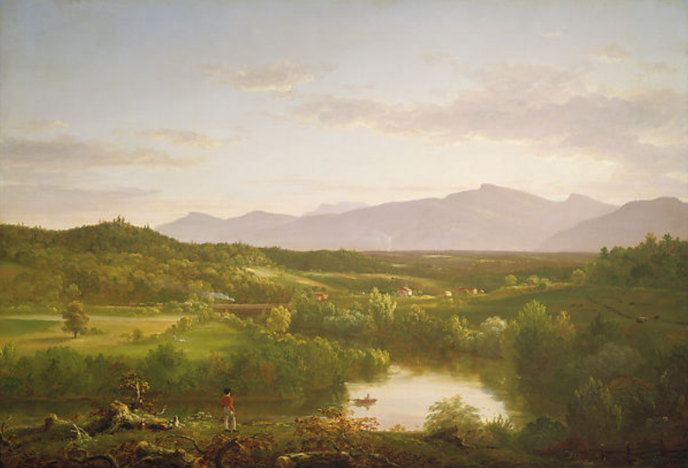
Thomas Cole (1801-1848), River in the Catskills, 1843. Oil on canvas, 27 ½ x 40 3/8 in., Museum of Fine Arts, Boston. Gift of Martha C. Karolik for the M. and M. Karolik Collection of American Paintings, 1815-1865, 47.1201. Photograph © 2022 Museum of Fine Arts, Boston

Cover Image: Asher B. Durand (1796-1886), Kindred Spirits (detail), 1849. Oil on canvas, 44 x 36 in., Crystal Bridges Museum of American Art, Bentonville, Arkansas, 2010.106

Thomas Cole National Historic Site
The Thomas Cole National Historic Site is an international destination presenting the original home and studios of the artist and early environmentalist Thomas Cole (1801-1848). Cole founded the major art movement of the United States, now known as the Hudson River School of landscape painting. Located on 6 acres in the Hudson Valley, the site includes the 1815 Main House; Cole’s 1839 Old Studio; the reconstructed 1846 New Studio building; and panoramic views of the Catskill Mountains. It is a National Historic Landmark and an affiliated area of the National Park System. The Thomas Cole Site’s activities include guided and self-guided tours, special exhibitions of both 19th-century and contemporary art, print publications, lectures, extensive online programs, school programs, the Cole Fellowship, free community events, and innovative public programs such as the Hudson River School Art Trail—a map and website that enable people to visit the places in nature that Cole painted—and the Hudson River Skywalk, a new scenic walkway connecting the Thomas Cole Site with Frederic Church’s Olana over the Hudson River. The goal of all programs at the Thomas Cole Site is to enable visitors to find meaning and inspiration in the full historic context of Thomas Cole’s art and ideas. The themes that Cole explored in his art and writings—such as landscape preservation—are both historic and timely, providing the opportunity to connect to audiences with insights that are highly relevant to their own lives.

Visitor Information
The hours of the Thomas Cole National Historic Site vary by season. For details see: www.thomascole.org/visit. The grounds are open every day for free from dawn to dusk. Keep in touch on Facebook, Instagram, and Twitter at @thomascolesite.

